**DAILY ONLINE ACTIVITIES SUMMARY**

|  |  |  |  |  |  |  |  |
| --- | --- | --- | --- | --- | --- | --- | --- |
| **Date:** | **23-05-2020** | | | | **Name:** | **B.A.SOHANKUMAR** | |
| **Sem & Sec** | **4TH SEM A** | | | | **USN:** | **4AL18CS013** | |
| **Online Test Summary** | | | | | | | |
| **Subject** | | **DATA COMMUNICATION(18CS46)** | | | | | |
| **Max. Marks** | | **30** | | **Score** | | **22** | |
| **Certification Course Summary** | | | | | | | |
| **Course** | **PYTHON FOR MACHINE LEARNING** | | | | | | |
| **Certificate Provider** | | | **GREAT LEARNING ACADEMY** | **Duration** | | | **5 HOURS** |
| **Coding Challenges** | | | | | | | |
| **Problem Statement:1.Write a c program to generate first N triangular number.(Where N is read from the keyboard).** | | | | | | | |
| **Status:Executed** | | | | | | | |
| **Uploaded the report in Github** | | | | **YES** | | | |
| **If yes Repository name** | | | | **LOCKDOWN CODING** | | | |
| **Uploaded the report in slack** | | | | **YES** | | | |

**ONLINE TEST DETAILS:**

Today online test was on DATA COMMUNICATION (18CS46) on first and second module.Duration of the time was 40 minutes from 9.15am to 9.55am.30 questions of multiple choice.The score of the test is 22/30.

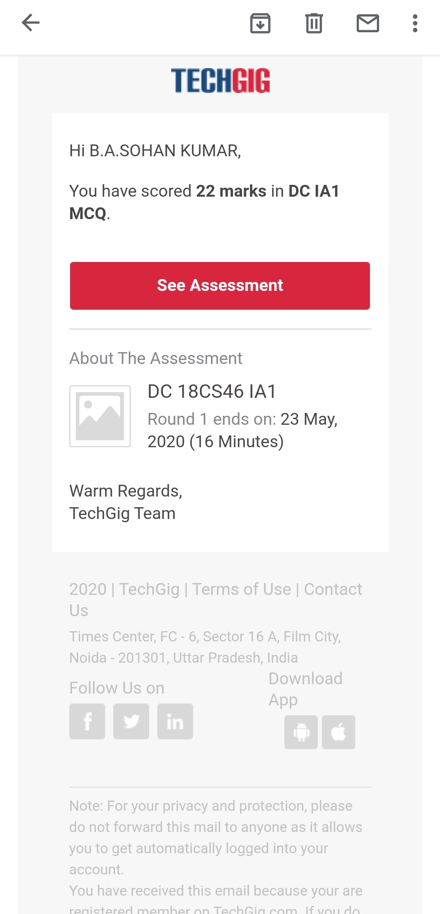

**CERTIFICATION COURSE DETAILS:**

Course: PYTHON FOR MACHINE LEARNING

Python is an easy to learn, powerful programming language. You can use Python when your data analysis tasks need to be integrated with web apps or if statistics code needs to be incorporated into a production database. Being a full-fledged programming language, it’s a great tool to implement algorithms for production use.While the infancy of Python packages for data analysis was an issue in the past, this has improved significantly over the years.

Today completed with 4 topics :Why Python, Python vs R, python IDE,Anaconda installation, Intro to Jupyter notebook,Jupyter Notebook shortcuts,Data Structures.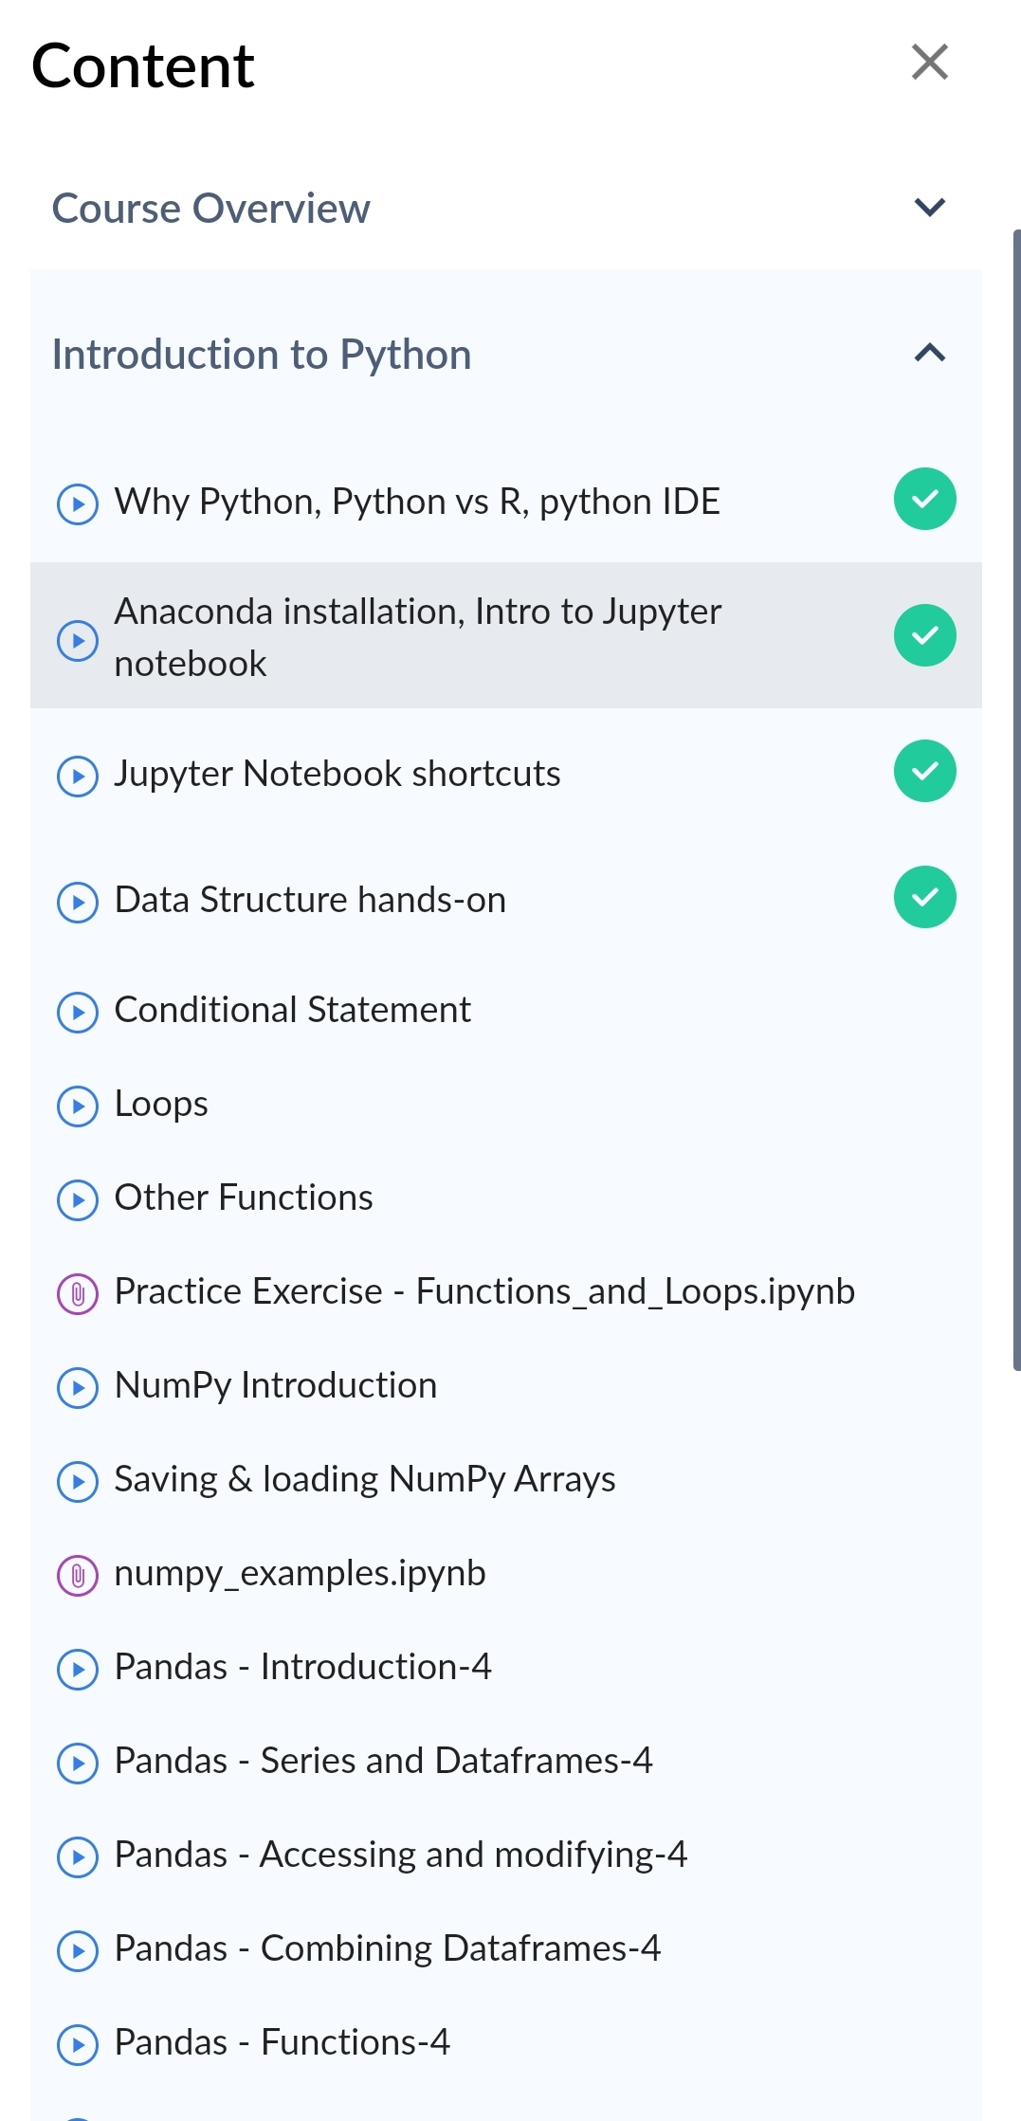**CODING CHALLENGE DETAILS:**

Write a C program to generate first N triangular number(Where N read from the keyboard).

Triangular Number series:A triangular number or triangle number counts the object that can form an equilateral triangle .The n triangle number is the number of dots or balls in a triangle with n dots on a side.It is the sum of the n natural numbers from 1 to n.

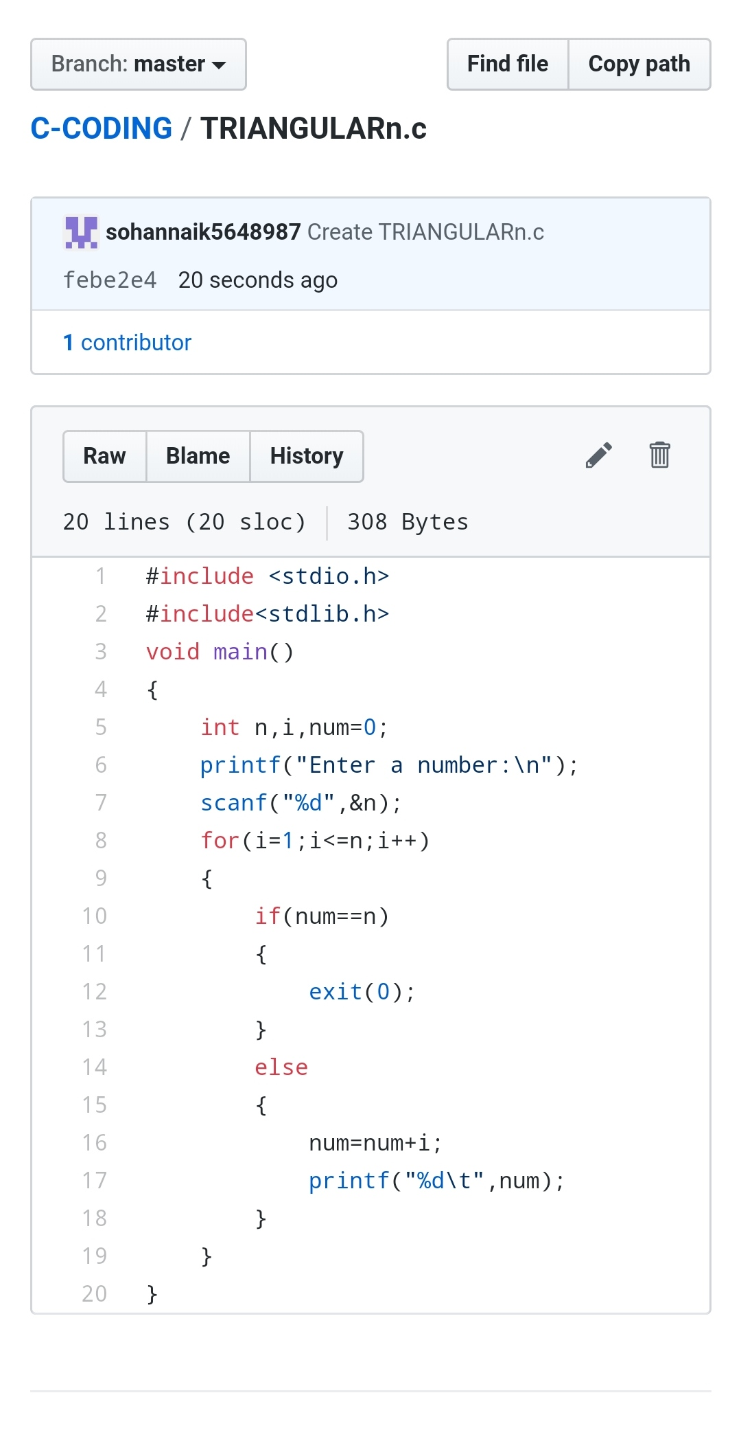

REPOSITORY LINK:https://github.com/sohannaik5648987/lockdown-coding